**NAME:**  Sudharshan R 185001173

**EX-NO:** 1

**EX-NAME:** Website for international Peace conference using html tags.

**Date:9-2-2020**

**OBJECTIVE:**

To implement the html tags to create a website for international Peace conference.

Specifications:

1. The conference homepage should consist of the following tabs: Home, Committee, Call for Papers, Important Dates, Workshops, Registration and Contact.

2. On clicking each tab, it should open in a separate page.

3. The website should contain background Image, logos, header, footer.

4. Use tooltip text for help.

5. For pre-conference workshop registration use form elements.

6. Mandatory Tags: List, Table, Anchor, Image, Semantic Tags

**INDEX:**

<!DOCTYPE html>

<html>

<head>

<meta charset="utf-8">

<meta name="viewport" content="width=device-width">

<title>International Conference </title>

</head>

<body background="bg1.jpg">

<header>

<h1 style="color:red;text-align:center;" title="Header"> <img src= "logo.jpg" alt="logo" width="30" height="30"> International conference on World Peace </h1>

</header>

<h3 title="Greetings">Welcome to International confernce on world peace...</h3>

<nav style="text-align:center;">

<a href="index.html" title="Takes to home" style="color:black;text-decoration:none; background-color:lightblue; text-align:center; "> Home </a>|

    <a href="committee.html" title="Committee Members" style="color:black;text-decoration:none; background-color:lightblue; text-align:center; "> Committee </a>|

    <a href="cfp.html" title="Call for papers" style="color:black;text-decoration:none; background-color:lightblue; text-align:center; "> Call for Papers </a>|

    <a href="imp_dates.html" title="Upcoming Important Dates" style="color:black;text-decoration:none; background-color:lightblue; text-align:center; "> Important Dates </a>|

    <a href="workshops.html" title="Show Workshops" style="color:black;text-decoration:none; background-color:lightblue; text-align:center; "> Workshops </a>|

    <a href="reg.html" title = "NEW! register here" style="color:black;text-decoration:none; background-color:lightblue; text-align:center; "> Registration </a>|

    <a href="contact.html" title="Help! contacts here" style="color:black;text-decoration:none; background-color:lightblue; text-align:center; "> Contact </a>

</nav>

<br>

<figure>

<img src= "dove.jpg" alt="dove" width="400" height="400">

</figure>

<h2 style="text-align:center;">INTERNATIONAL PEACE CONFERENCE 2020: THE EYELAND</h2>

<p style="text-align:center;">The sixth annual International Peace Conference is fast approaching and will be taking place from Feb 13th-15th in Maastricht, Netherlands

​Explore and learn more about the conference and our upcoming theme: "The Eyeland"</p>

<details>

<summary title="click to expand">About</summary>

<p>

Within the global spectrum, there are different spheres in which the realization of peace is determined by our choices. On the international level, choices made by global leaders and organizations have an immediate impact on ordinary citizens

unrepresented in the decision making. On the national and community level, choices and actions made by citizens bear responsibility, and shape the course that countries and communities take. On the personal level, choices affect

our well-being, inner peace, and relationship with others.

</p>

</details>

<details>

<summary title="click to expand">Our Philosophy</summary>

<p>

We firmly believe that there lies enormous potential for conflict resolution through unmediated dialogue and discussion, viewing it as a force to spread the profound possibility of global harmony. The conference is idealistic. This is what gives it its power. We aim to spark activism and initiative among youth.

</p>

<p>

With enormous commitment, hard work and perseverance; with cooperation, collaboration and understanding; by recognizing the barriers and obstacles that lie ahead, yet not merely accepting them, peace can be a reality.

</p>

</details>

<details>

<summary title="click to expand">The Conference</summary>

<p>

During a three-day conference, 400 participants of over 105 nationalities, take part in a wide variety of engagements. Workshops led by youth, who have either experienced the absence of peace or with personal ties to various forms of conflict, offer unique insights and solution-based discussions. Peacemakers, challengers, advocates, and experts from around the world share their knowledge and inspire through lectures and leaded debates. The intercultural evenings and performances add a sense of optimism and understanding, a sense of hope and purpose.

</p>

</details>

<footer>

<p style="color:red;">Developed using HTML5</p>

<p title="mail here for any help"><a href="mailto:helpline@conf.com">helpline@conf.com</a></p>

</footer>

  </body>

</html>

<!DOCTYPE html>

<html>

<head>

<meta charset="utf-8">

<meta name="viewport" content="width=device-width">

<title>International Conference </title>

</head>

<body background="bg1.jpg">

<header>

<h1 style="color:red;text-align:center;" title="Header"> <img src= "logo.jpg" alt="logo" width="30" height="30"> International conference on World Peace </h1>

</header>

<h3 title="Greetings">Welcome to International confernce on world peace...</h3>

<nav style="text-align:center;">

<a href="index.html" title="Takes to home" style="color:black;text-decoration:none; background-color:lightblue; text-align:center; "> Home </a>|

    <a href="committee.html" title="Committee Members" style="color:black;text-decoration:none; background-color:lightblue; text-align:center; "> Committee </a>|

    <a href="cfp.html" title="Call for papers" style="color:black;text-decoration:none; background-color:lightblue; text-align:center; "> Call for Papers </a>|

    <a href="imp_dates.html" title="Upcoming Important Dates" style="color:black;text-decoration:none; background-color:lightblue; text-align:center; "> Important Dates </a>|

    <a href="workshops.html" title="Show Workshops" style="color:black;text-decoration:none; background-color:lightblue; text-align:center; "> Workshops </a>|

    <a href="reg.html" title = "NEW! register here" style="color:black;text-decoration:none; background-color:lightblue; text-align:center; "> Registration </a>|

    <a href="contact.html" title="Help! contacts here" style="color:black;text-decoration:none; background-color:lightblue; text-align:center; "> Contact </a>

</nav>

<br>

<h2 style="text-align:center;">INTERNATIONAL PEACE CONFERENCE 2020: THE EYELAND</h2>

<p ><img src="ines.jpg" alt="INES" height="300" width="200" style="float:left;padding:50px">

<h1><strong>Ines Chami</strong></h1><br>

<h3><em>Morroco</em> / <strong>Conference Content</strong></h3>

<br>

<p style="width:700px;">In my opinion peace doesn’t mean absence of war. For me it’s the absence of violence. Peace is an activity. It’s a commitment that is practiced every day in all our interactions. Peace is a relationship of good living together, solid and sustainable based on respect, serenity, cordiality between all humans but also any form of life on earth. That is why I joined the International Peace conference, I wanted to propagate peace and no violence. Make the world a better place where everyone can live together and help each other.</p>

<br>

<br>

<p ><img src="can.jpg" alt="CAN" height="300" width="200" style="float:left;padding:50px">

<h1><strong>Can Talu Mavioglu</strong></h1><br>

<h3><em>Turkey</em> / <strong>Communications</strong></h3>

<br>

<p style="width:700px;">If we try to find a definition for peace, we may be arguing for hours and never reach an agreement. But what would take us less than a second is to concur on what peace will never be: A Fighting. A war. A battle. A combat. Nevertheless, I come from a place where I have never seen an armed conflict, but that cannot be said to be in peace. I want to probe this apparent relativity of the concept of peace, while getting the opportunity to know other points of view; and I know IPC is the best place to do so.</p>

<br>

<br>

<p ><img src="annemarie.jpg" alt="Anne-Marie" height="300" width="200" style="float:left;padding:50px">

<h1><strong>Anne-Marie Gendron</strong></h1><br>

<h3><em>Canada</em> / <strong>Logistics, Finance</strong></h3>

<p style="width:700px;">I perceive peace as an everlasting journey, as an ideal that we constantly need to strive for. Peace, for me, is about questioning our actions and our achievements in an attempt to create evolution in the world as we know it. I think that individuals like me, who are born with the privilege of not knowing war, have to acknowledge that they have a responsibility to aim and work for achieving equality, non-violence and respect. The absence of conflict might be utopian, but understanding each other’s mindset and being capable of introspection is a meaningful step that we can all take. IPC 2020 is for me the occasion to put those ideas into action, for myself, for the community, and for the world. </p>

<br>

<br>

<footer>

<p style="color:red;">Developed using HTML5</p>

<p title="mail here for any help"><a href="mailto:helpline@conf.com">helpline@conf.com</a></p>

</footer>

  </body>

</html>

**COMMITTEE:**

<!DOCTYPE html>

<html>

<head>

<meta charset="utf-8">

<meta name="viewport" content="width=device-width">

<title>International Conference </title>

</head>

<body background="bg1.jpg">

<header>

<h1 style="color:red;text-align:center;" title="Header"> <img src= "logo.jpg" alt="logo" width="30" height="30"> International conference on World Peace </h1>

</header>

<h3 title="Greetings">Welcome to International confernce on world peace...</h3>

<nav style="text-align:center;">

<a href="index.html" title="Takes to home" style="color:black;text-decoration:none; background-color:lightblue; text-align:center; "> Home </a>|

    <a href="committee.html" title="Committee Members" style="color:black;text-decoration:none; background-color:lightblue; text-align:center; "> Committee </a>|

    <a href="cfp.html" title="Call for papers" style="color:black;text-decoration:none; background-color:lightblue; text-align:center; "> Call for Papers </a>|

    <a href="imp_dates.html" title="Upcoming Important Dates" style="color:black;text-decoration:none; background-color:lightblue; text-align:center; "> Important Dates </a>|

    <a href="workshops.html" title="Show Workshops" style="color:black;text-decoration:none; background-color:lightblue; text-align:center; "> Workshops </a>|

    <a href="reg.html" title = "NEW! register here" style="color:black;text-decoration:none; background-color:lightblue; text-align:center; "> Registration </a>|

    <a href="contact.html" title="Help! contacts here" style="color:black;text-decoration:none; background-color:lightblue; text-align:center; "> Contact </a>

</nav>

<br>

<h2 style="text-align:center;">INTERNATIONAL PEACE CONFERENCE 2020: THE EYELAND</h2>

<p ><img src="ines.jpg" alt="INES" height="300" width="200" style="float:left;padding:50px">

<h1><strong>Ines Chami</strong></h1><br>

<h3><em>Morroco</em> / <strong>Conference Content</strong></h3>

<br>

<p style="width:700px;">In my opinion peace doesn’t mean absence of war. For me it’s the absence of violence. Peace is an activity. It’s a commitment that is practiced every day in all our interactions. Peace is a relationship of good living together, solid and sustainable based on respect, serenity, cordiality between all humans but also any form of life on earth. That is why I joined the International Peace conference, I wanted to propagate peace and no violence. Make the world a better place where everyone can live together and help each other.</p>

<br>

<br>

<p ><img src="can.jpg" alt="CAN" height="300" width="200" style="float:left;padding:50px">

<h1><strong>Can Talu Mavioglu</strong></h1><br>

<h3><em>Turkey</em> / <strong>Communications</strong></h3>

<br>

<p style="width:700px;">If we try to find a definition for peace, we may be arguing for hours and never reach an agreement. But what would take us less than a second is to concur on what peace will never be: A Fighting. A war. A battle. A combat. Nevertheless, I come from a place where I have never seen an armed conflict, but that cannot be said to be in peace. I want to probe this apparent relativity of the concept of peace, while getting the opportunity to know other points of view; and I know IPC is the best place to do so.</p>

<br>

<br>

<p ><img src="annemarie.jpg" alt="Anne-Marie" height="300" width="200" style="float:left;padding:50px">

<h1><strong>Anne-Marie Gendron</strong></h1><br>

<h3><em>Canada</em> / <strong>Logistics, Finance</strong></h3>

<p style="width:700px;">I perceive peace as an everlasting journey, as an ideal that we constantly need to strive for. Peace, for me, is about questioning our actions and our achievements in an attempt to create evolution in the world as we know it. I think that individuals like me, who are born with the privilege of not knowing war, have to acknowledge that they have a responsibility to aim and work for achieving equality, non-violence and respect. The absence of conflict might be utopian, but understanding each other’s mindset and being capable of introspection is a meaningful step that we can all take. IPC 2020 is for me the occasion to put those ideas into action, for myself, for the community, and for the world. </p>

<br>

<br>

<footer>

<p style="color:red;">Developed using HTML5</p>

<p title="mail here for any help"><a href="mailto:helpline@conf.com">helpline@conf.com</a></p>

</footer>

  </body>

</html>

**CALL FOR PAPERS:**

<!DOCTYPE html>

<html>

<head>

<meta charset="utf-8">

<meta name="viewport" content="width=device-width">

<title>International Conference </title>

</head>

<body background="bg1.jpg">

<header>

<h1 style="color:red;text-align:center;" title="Header"> <img src= "logo.jpg" alt="logo" width="30" height="30"> International conference on World Peace </h1>

</header>

<h3 title="Greetings">Welcome to International confernce on world peace...</h3>

<nav style="text-align:center;">

<a href="index.html" title="Takes to home" style="color:black;text-decoration:none; background-color:lightblue; text-align:center; "> Home </a>|

    <a href="committee.html" title="Committee Members" style="color:black;text-decoration:none; background-color:lightblue; text-align:center; "> Committee </a>|

    <a href="cfp.html" title="Call for papers" style="color:black;text-decoration:none; background-color:lightblue; text-align:center; "> Call for Papers </a>|

    <a href="imp_dates.html" title="Upcoming Important Dates" style="color:black;text-decoration:none; background-color:lightblue; text-align:center; "> Important Dates </a>|

    <a href="workshops.html" title="Show Workshops" style="color:black;text-decoration:none; background-color:lightblue; text-align:center; "> Workshops </a>|

    <a href="reg.html" title = "NEW! register here" style="color:black;text-decoration:none; background-color:lightblue; text-align:center; "> Registration </a>|

    <a href="contact.html" title="Help! contacts here" style="color:black;text-decoration:none; background-color:lightblue; text-align:center; "> Contact </a>

</nav>

<br>

<h1> Call for Papers</h1>

<p>

8th Peace and Conflict Resolution Conference [PCRC2021] accepts the following types of submissions:

</p>

<ul>

<li><strong>Research Papers:</strong> Completed research papers in any of the topic areas listed bellow or related areas.</li>

<li><strong>Abstracts:</strong> Abstracts of completed or proposed research in any of the topic areas listed bellow, or related areas. The abstract for proposed research should include the research objectives, proposed methodology, and a discussion of expected outcomes.</li>

<li><strong>Student Papers:</strong> Research done by students in any of the topic areas listed bellow, or related areas.</li>

<li><strong>Case Studies:</strong> Case studies in any of the topic areas listed bellow, or related areas.</li>

<li><strong>Work-in-Progress Reports or Proposals for Future Research: </strong>Incomplete research or ideas for future research in order to generate discussion and feedback in any of related areas.</li>

<li><strong>Reports on Issues Related to the conference topics: </strong>Reports related to innovative techniques or research related to any of the topic areas listed bellow or related areas.</li>

</ul>

<p>Proposals are accepted on a rolling admission basis as long as space is available or by <strong>September 10th 2021</strong> at the latest and are to be be submitted along with application form. All submissions will be peer reviewed and acceptance/rejections is based on their relevance to the conference topics. Notification on acceptance is sent within 7 days after the submissions has been received.</p>

<br>

<footer>

<p style="color:red;">Developed using HTML5</p>

<p title="mail here for any help"><a href="mailto:helpline@conf.com">helpline@conf.com</a></p>

</footer>

  </body>

</html>

**IMPORTANT DATES:**

<!DOCTYPE html>

<html>

<head>

<meta charset="utf-8">

<meta name="viewport" content="width=device-width">

<title>International Conference </title>

</head>

<body background="bg1.jpg">

<header>

<h1 style="color:red;text-align:center;" title="Header"> <img src= "logo.jpg" alt="logo" width="30" height="30"> International conference on World Peace </h1>

</header>

<h3 title="Greetings">Welcome to International confernce on world peace...</h3>

<nav style="text-align:center;">

<a href="index.html" title="Takes to home" style="color:black;text-decoration:none; background-color:lightblue; text-align:center; "> Home </a>|

    <a href="committee.html" title="Committee Members" style="color:black;text-decoration:none; background-color:lightblue; text-align:center; "> Committee </a>|

    <a href="cfp.html" title="Call for papers" style="color:black;text-decoration:none; background-color:lightblue; text-align:center; "> Call for Papers </a>|

    <a href="imp_dates.html" title="Upcoming Important Dates" style="color:black;text-decoration:none; background-color:lightblue; text-align:center; "> Important Dates </a>|

    <a href="workshops.html" title="Show Workshops" style="color:black;text-decoration:none; background-color:lightblue; text-align:center; "> Workshops </a>|

    <a href="reg.html" title = "NEW! register here" style="color:black;text-decoration:none; background-color:lightblue; text-align:center; "> Registration </a>|

    <a href="contact.html" title="Help! contacts here" style="color:black;text-decoration:none; background-color:lightblue; text-align:center; "> Contact </a>

</nav>

<br>

<table border=1 style="border-collapse:collapse;margin-left :auto;margin-right :auto;">

<thead style="background-color:bisque;">

<tr>

<th colspan=3>Thursday ,February 13<sup>th</sup> 2020</th>

</tr>

<tr>

<th>Time</th>

<th>Event</th>

<th>Location</th>

</thead>

<tbody>

<tr>

<td> 17:45 - 19:00</td>

<td> Dinner </td>

<td> Mensa </td>

</tr>

<tr>

<td> 18:40 - 19:10 </td>

<td> Buses to Venue </td>

<td> UWCM </td>

</tr>

<tr>

<td> 19:30 - 21:10 </td>

<td> Opening ceremony </td>

<td> Sint-Janskerk </td>

</tr>

<tr>

<td> 21:15 - 21:45 </td>

<td> Buses to UWCM </td>

<td> Sint-Janskerk </td>

</tr>

</tbody>

</table>

<br>

<table border=1 style="border-collapse:collapse;margin-left :auto;margin-right :auto;">

<thead style="background-color:bisque;">

<tr>

<th colspan=3>Friday ,February 14<sup>th</sup> 2020</th>

</tr>

<tr>

<th>Time</th>

<th>Event</th>

<th>Location</th>

</thead>

<tbody>

<tr>

<td> 8:10 - 12:15 </td>

<td> Class </td>

<td> School Building </td>

</tr>

<tr>

<td> 12:20 - 13:20 </td>

<td> Lunch </td>

<td> Mensa </td>

</tr>

<tr>

<td> 13:30 - 14:30 </td>

<td> 1<sup>st</sup> round of experiences </td>

<td> School Building </td>

</tr>

<tr>

<td> 14:30 - 14:45 </td>

<td> Break</td>

<td> School Building </td>

</tr>

<tr>

<td> 14:45 - 16:15 </td>

<td> Speaker</td>

<td> Atrium </td>

</tr>

<tr>

<td> 16:15 - 17:15 </td>

<td> 2<sup> nd</sup> round of Experiences</td>

<td>School Building </td>

</tr>

<tr>

<td> 17:45 - 19:00 </td>

<td> Banquet of Versailles</td>

<td> Mensa </td>

</tr>

<tr>

<td> 19:00 - 21:00 </td>

<td> Art Exhibition </td>

<td> School Building </td>

</tr>

</tbody>

</table>

<br>

<table border=1 style="border-collapse:collapse;margin-left :auto;margin-right :auto;">

<thead style="background-color:bisque;">

<tr>

<th colspan=3>Saturday ,February 15<sup>th</sup> 2020</th>

</tr>

<tr>

<th>Time</th>

<th>Event</th>

<th>Location</th>

</thead>

<tbody>

<tr>

<td> 10:00 - 11:00</td>

<td> Brunch </td>

<td> Mensa </td>

</tr>

<tr>

<td> 11:30 - 14:00 </td>

<td> Fragments of conflict </td>

<td> Atrium </td>

</tr>

<tr>

<td> 13:00 - 14:30 </td>

<td> Closing ceremony </td>

<td> Atrium </td>

</tr>

</tbody>

</table>

<br>

</table>

<footer>

<p style="color:red;">Developed using HTML5</p>

<p title="mail here for any help"><a href="mailto:helpline@conf.com">helpline@conf.com</a></p>

</footer>

  </body>

</html>

**WORKSHOPS:**

<!DOCTYPE html>

<html>

<head>

<meta charset="utf-8">

<meta name="viewport" content="width=device-width">

<title>International Conference </title>

</head>

<body background="bg1.jpg">

<header>

<h1 style="color:red;text-align:center;" title="Header"> <img src= "logo.jpg" alt="logo" width="30" height="30"> International conference on World Peace </h1>

</header>

<h3 title="Greetings">Welcome to International confernce on world peace...</h3>

<nav style="text-align:center;">

<a href="index.html" title="Takes to home" style="color:black;text-decoration:none; background-color:lightblue; text-align:center; "> Home </a>|

    <a href="committee.html" title="Committee Members" style="color:black;text-decoration:none; background-color:lightblue; text-align:center; "> Committee </a>|

    <a href="cfp.html" title="Call for papers" style="color:black;text-decoration:none; background-color:lightblue; text-align:center; "> Call for Papers </a>|

    <a href="imp_dates.html" title="Upcoming Important Dates" style="color:black;text-decoration:none; background-color:lightblue; text-align:center; "> Important Dates </a>|

    <a href="workshops.html" title="Show Workshops" style="color:black;text-decoration:none; background-color:lightblue; text-align:center; "> Workshops </a>|

    <a href="reg.html" title = "NEW! register here" style="color:black;text-decoration:none; background-color:lightblue; text-align:center; "> Registration </a>|

    <a href="contact.html" title="Help! contacts here" style="color:black;text-decoration:none; background-color:lightblue; text-align:center; "> Contact </a>

</nav>

<br>

<p ><img src="yumika.jpg" alt="Yumika" height="300" width="300" style="float:left;padding:50px">

<h1><strong>The Truth Behind a History</strong></h1>

<h3>Elsa, Yumika and Nicolas</h3>

<p style="width:700px;">Have you ever found out that history is not what your textbook says?Have you ever found out that there is always something else to the “history” you are told?Have you ever doubted that?Sometimes you may find two documents talking about the same history, but with completely opposite perspectives.What is the truth then? Who should you believe? Why is it different?To what extent will history affect people’s opinions about the world now?You are the detective now. Come and find the truth.

</p>

<br>

<br>

<br>

<p ><img src="borris.jpg" alt="Boris" height="300" width="300" style="float:left;padding:50px">

<h1><strong>From Nationalism to Immigration</strong></h1><br>

<h3>Boris</h3>

<br>

<p style="width:700px;">Some argue that, in today’s globalized world, migration is causing an erosion of borders and sovereignty.

Some others thank this global phenomenon migration for connecting different societies and powering growth.Who is right and who is wrong, if anyone at all?</p>

<br>

<br>

<br>

<footer>

<p style="color:red;">Developed using HTML5</p>

<p title="mail here for any help"><a href="mailto:helpline@conf.com">helpline@conf.com</a></p>

</footer>

  </body>

</html>

**REGISTRATION:**

<!DOCTYPE html>

<html>

<head>

<meta charset="utf-8">

<meta name="viewport" content="width=device-width">

<title>International Conference </title>

</head>

<body background="bg1.jpg">

<header>

<h1 style="color:red;text-align:center;" title="Header"> <img src= "logo.jpg" alt="logo" width="30" height="30"> International conference on World Peace </h1>

</header>

<h3 title="Greetings">Welcome to International confernce on world peace...</h3>

<nav style="text-align:center;">

<a href="index.html" title="Takes to home" style="color:black;text-decoration:none; background-color:lightblue; text-align:center; "> Home </a>|

    <a href="committee.html" title="Committee Members" style="color:black;text-decoration:none; background-color:lightblue; text-align:center; "> Committee </a>|

    <a href="cfp.html" title="Call for papers" style="color:black;text-decoration:none; background-color:lightblue; text-align:center; "> Call for Papers </a>|

    <a href="imp_dates.html" title="Upcoming Important Dates" style="color:black;text-decoration:none; background-color:lightblue; text-align:center; "> Important Dates </a>|

    <a href="workshops.html" title="Show Workshops" style="color:black;text-decoration:none; background-color:lightblue; text-align:center; "> Workshops </a>|

    <a href="reg.html" title = "NEW! register here" style="color:black;text-decoration:none; background-color:lightblue; text-align:center; "> Registration </a>|

    <a href="contact.html" title="Help! contacts here" style="color:black;text-decoration:none; background-color:lightblue; text-align:center; "> Contact </a>

</nav>

<br>

<form>

<label for="fname">Name:</label><br><br>

<input type="text" id="fname" name="fname" value="First">

<input type="text" id="lname" name="lname" value="Last"><br><br>

<label for="gender">Gender:</label><br><br>

<select id="gender" name="gender">

<option value="Select">Select</option>

<option value="male">Male</option>

<option value="female">Female</option>

<option value="other">Other</option>

</select>

<br><br>

<label for="mail">Mail ID:</label><br><br>

<input type="text" id="mail" name="mail"><br><br>

<label for="consent">Do you consent to having your pictures taken and published? </label><br><br>

<input type="radio" id="yes" name="consent" value="yes">

<label for="male">Yes</label><br>

<input type="radio" id="no" name="consent" value="no">

<label for="female">No</label><br><br>

<input type="submit" value="Submit">

</form>

<footer>

<p style="color:red;">Developed using HTML5</p>

<p title="mail here for any help"><a href="mailto:helpline@conf.com">helpline@conf.com</a></p>

</footer>

  </body>

</html>

**CONTACT:**

<!DOCTYPE html>

<html>

<head>

<meta charset="utf-8">

<meta name="viewport" content="width=device-width">

<title>International Conference </title>

</head>

<body background="bg1.jpg">

<header>

<h1 style="color:red;text-align:center;" title="Header"> <img src= "logo.jpg" alt="logo" width="30" height="30"> International conference on World Peace </h1>

</header>

<h3 title="Greetings">Welcome to International confernce on world peace...</h3>

<nav style="text-align:center;">

<a href="index.html" title="Takes to home" style="color:black;text-decoration:none; background-color:lightblue; text-align:center; "> Home </a>|

    <a href="committee.html" title="Committee Members" style="color:black;text-decoration:none; background-color:lightblue; text-align:center; "> Committee </a>|

    <a href="cfp.html" title="Call for papers" style="color:black;text-decoration:none; background-color:lightblue; text-align:center; "> Call for Papers </a>|

    <a href="imp_dates.html" title="Upcoming Important Dates" style="color:black;text-decoration:none; background-color:lightblue; text-align:center; "> Important Dates </a>|

    <a href="workshops.html" title="Show Workshops" style="color:black;text-decoration:none; background-color:lightblue; text-align:center; "> Workshops </a>|

    <a href="reg.html" title = "NEW! register here" style="color:black;text-decoration:none; background-color:lightblue; text-align:center; "> Registration </a>|

    <a href="contact.html" title="Help! contacts here" style="color:black;text-decoration:none; background-color:lightblue; text-align:center; "> Contact </a>

</nav>

<br>

<figure>

<img src= "dove.jpg" alt="dove" width="400" height="400">

</figure>

<h2 style="text-align:center;">INTERNATIONAL PEACE CONFERENCE 2020: THE EYELAND</h2>

<p style="text-align:center;">The sixth annual International Peace Conference is fast approaching and will be taking place from Feb 13th-15th in Maastricht, Netherlands

​Explore and learn more about the conference and our upcoming theme: "The Eyeland"</p>

<footer>

<p><strong>Contact Number : </strong> 485601839</p>

<p style="color:red;">Developed using HTML5</p>

<p title="mail here for any help"><a href="mailto:helpline@conf.com">helpline@conf.com</a></p>

</footer>

  </body>

</html>

**IMAGES ADDED IN WEBSITE:**

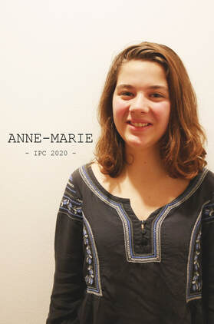 

 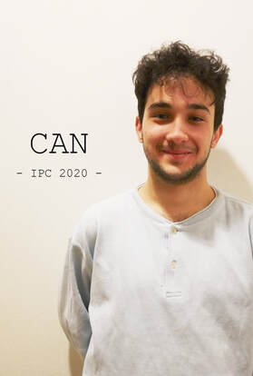 

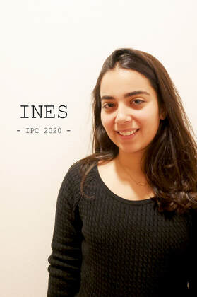  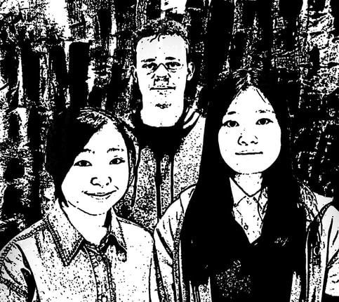

**WEBSITE OUTPUT SCREENSHOTS:**

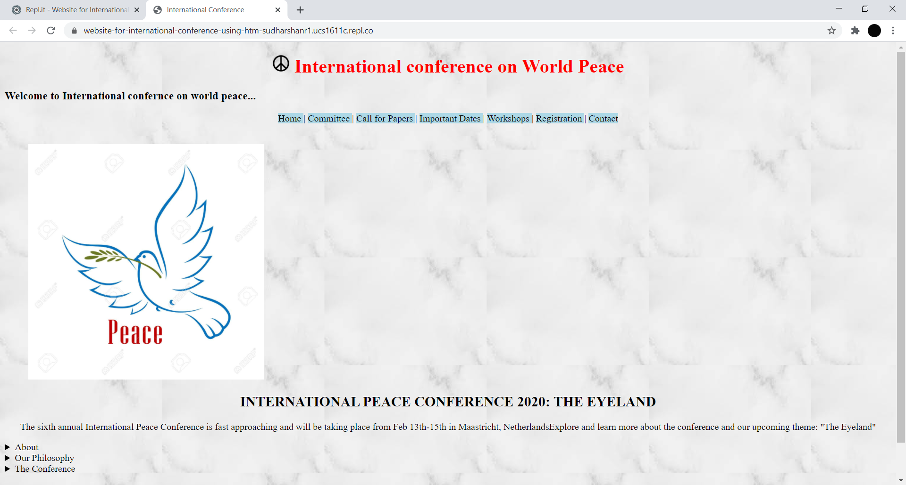

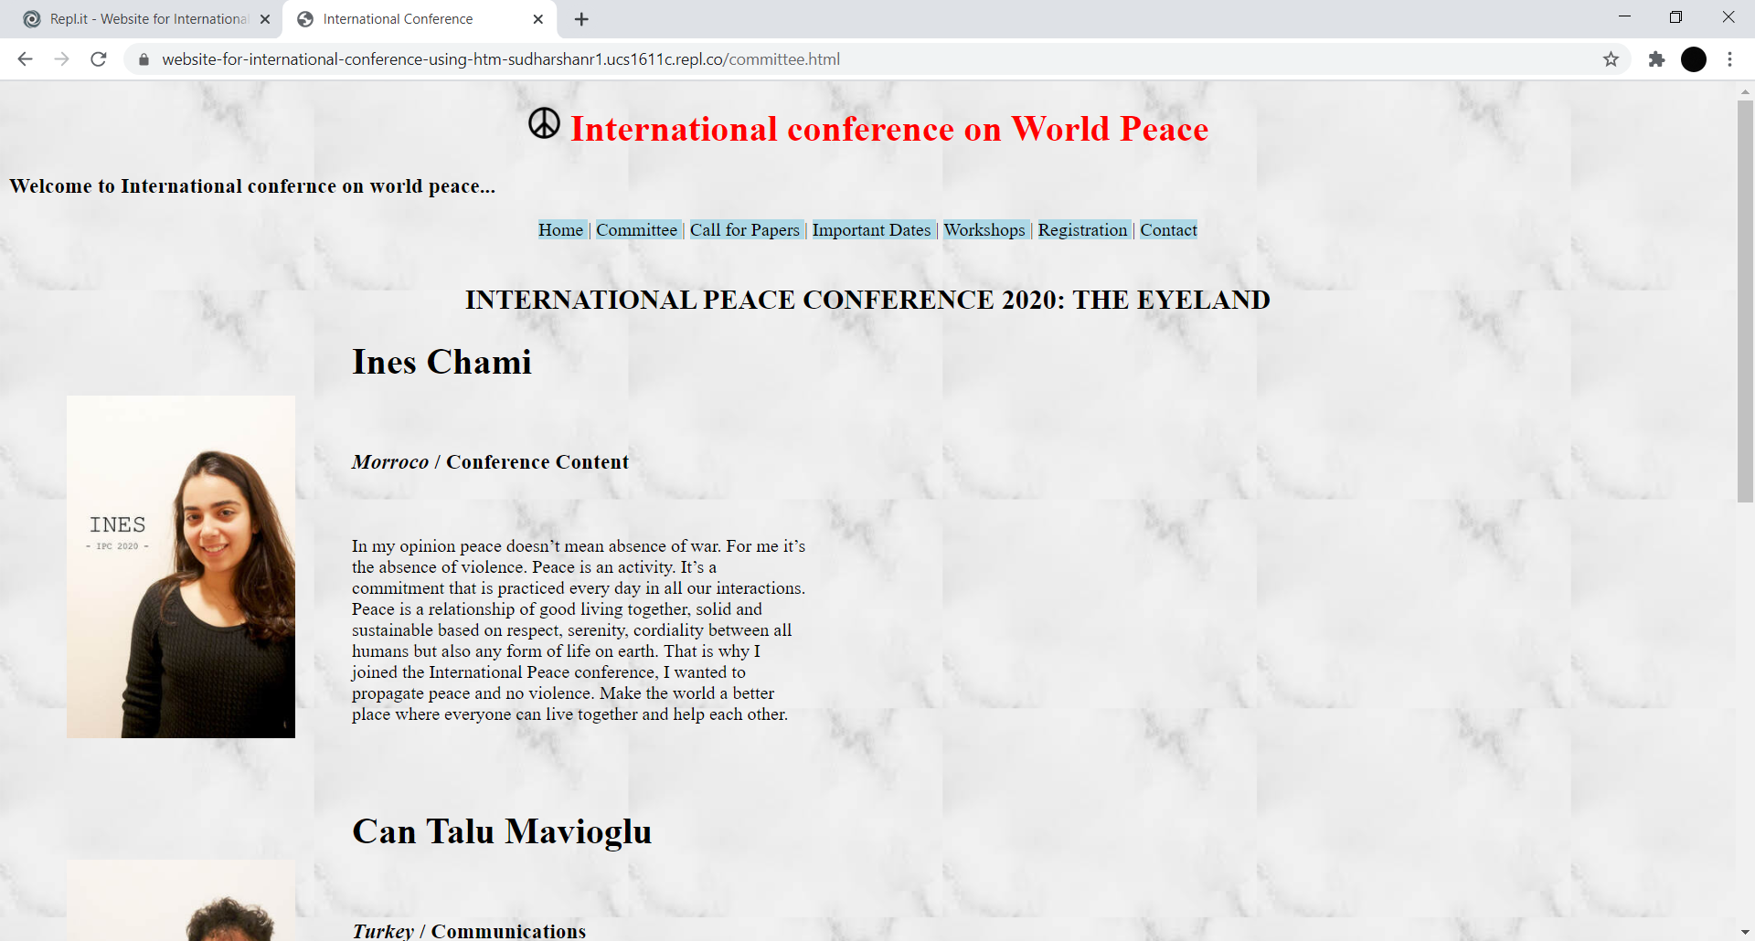

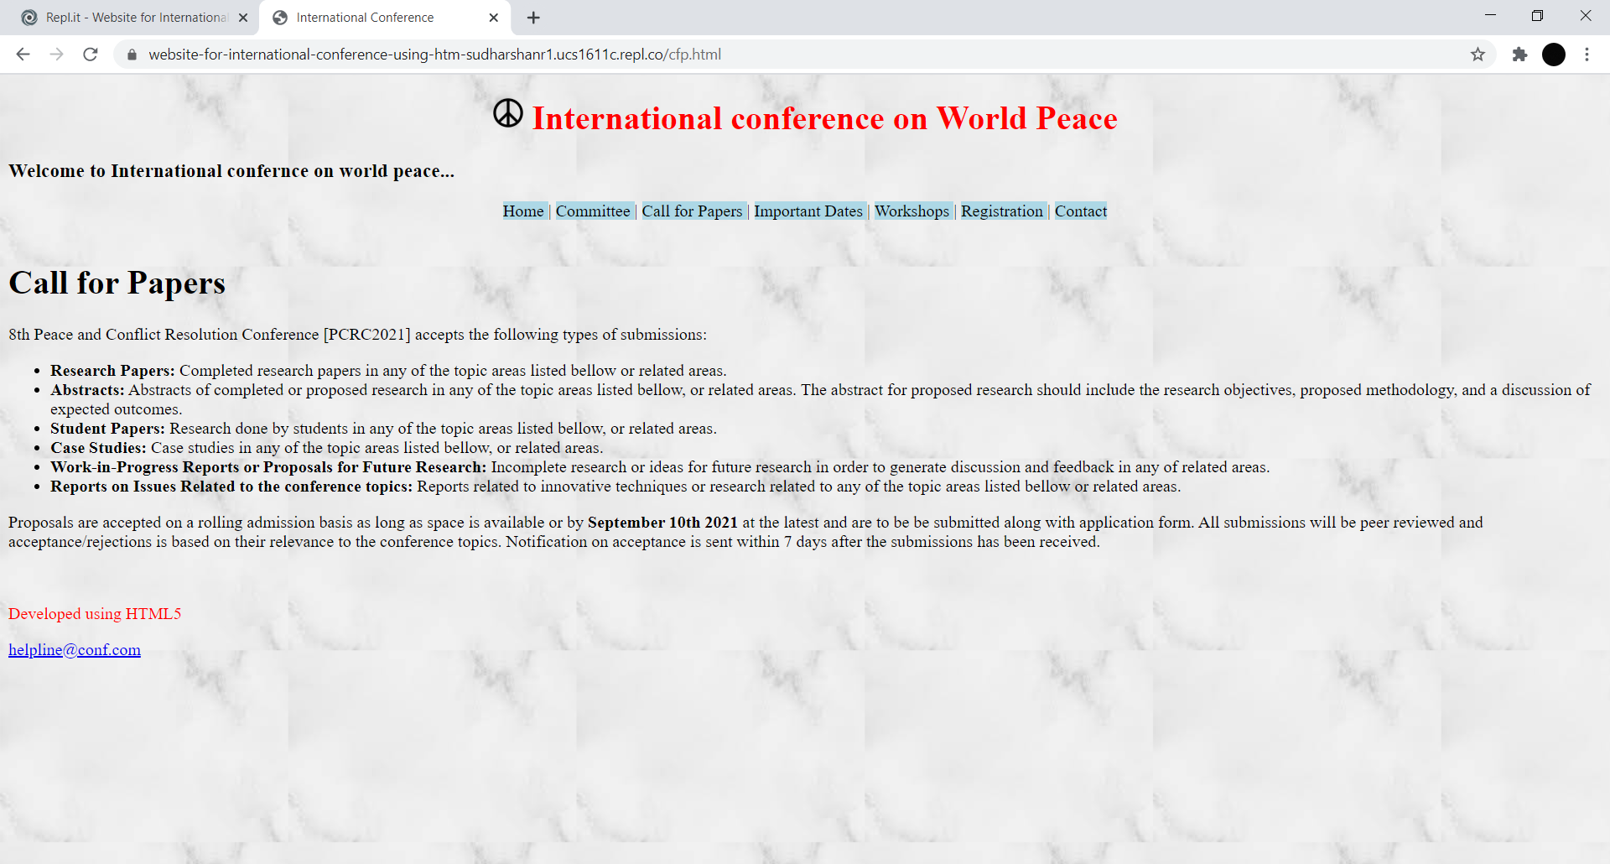

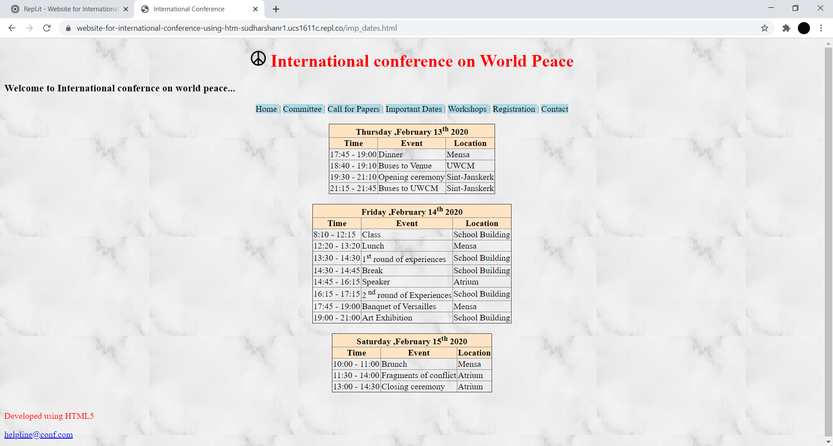

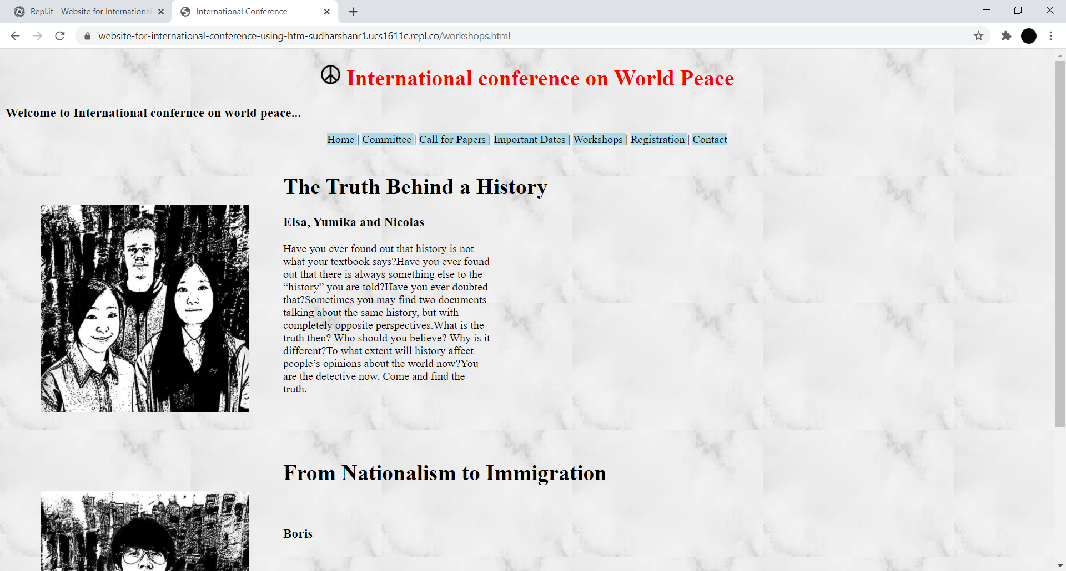

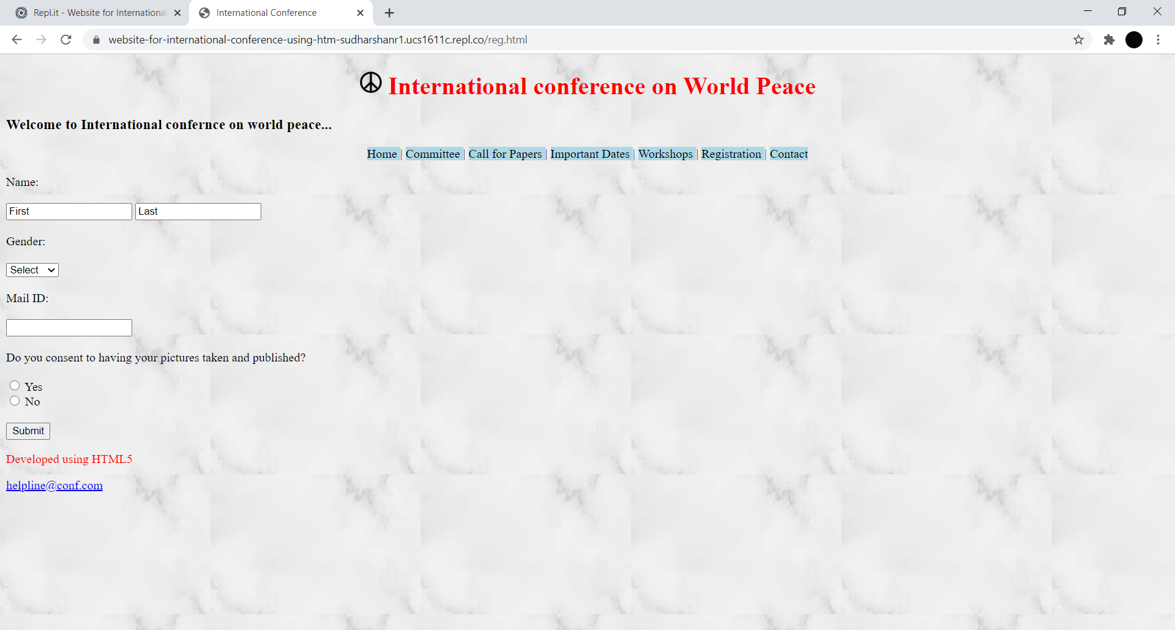

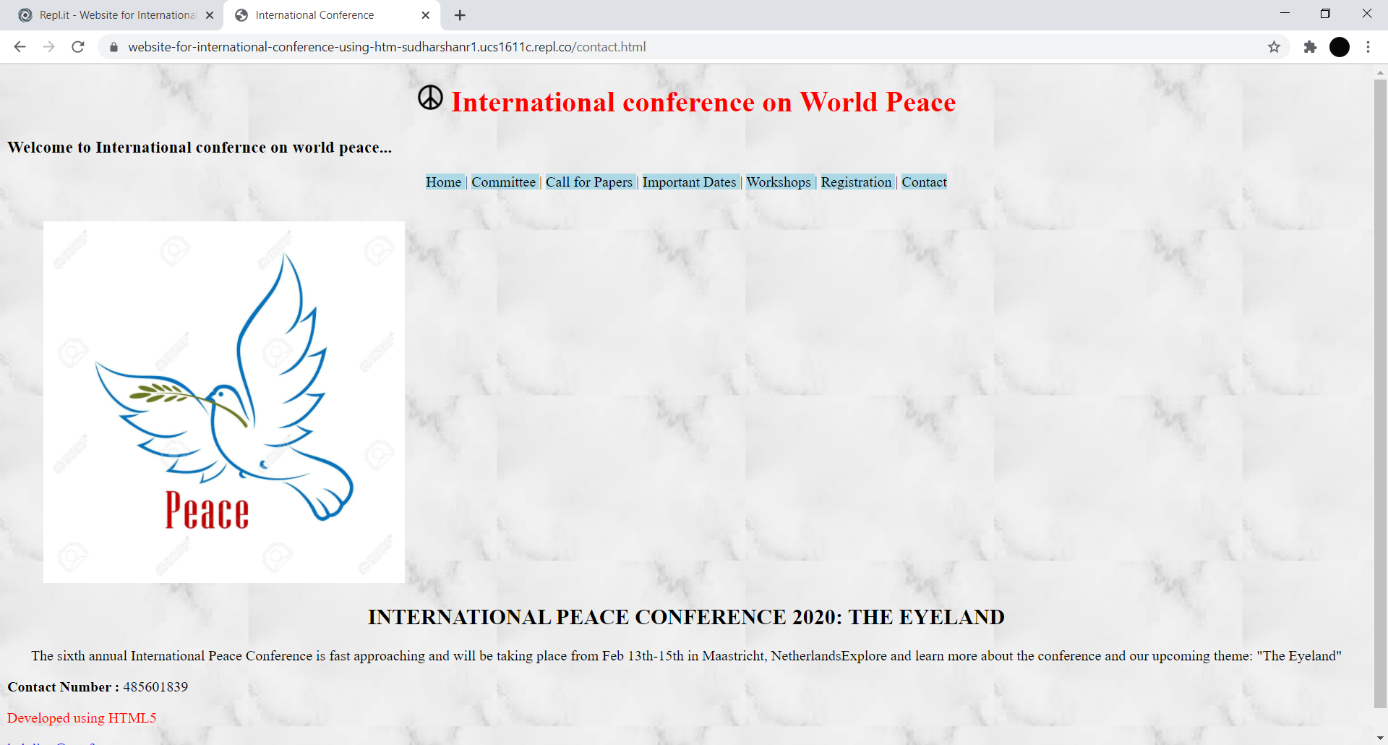

**LEARNING OUTCOME:**

* I learnt about the different uses of semantic tags and different types of them.
* Also learnt to implement images in html.
* Understood the usage of different Html form elements.
* Understood html links and anchor tags.
* Learnt about the basic inline CSS.